**Company Profile:-**

**Core Values**

Following concepts and ideas guide the SK Family Foods in conducting its business practices in most ethical ways.

**1. Ethical Conduct and Integrity**

We value truth, honesty, integrity and fair play as a basic ingredients while interacting within the company and dealing with the outside world.

**2. Teamwork and Responsibility**

We share information and resources in a professional way Conflicts are worked out in spite of obstacles and difficulties. We accept responsibility with “can do” attitude.

**3. Customer Satisfaction**

We endeavor to provide quality products to our customers at competitive prices. We value their satisfaction essential for continued growth of our business.

**4. Continuous Improvement**

Continuous improvement through new ideas and creative approach.

**Vision**

* Our passion is to attain a distinctive leadership amongst the food supply chain.
* We SK Family Foods recognize that the realization of this passion professional competencies, continuous value addition and improvising.
* Our commitment to food safety as per national and international standards.

**Mission**

* To the premium and preferred supply source of food products.
* Offer products that are not only viable in terms of desirability and price but most importantly give true and lasting value to our customers.
* Business development by adoption of best available food products in local and international market.
* Be a responsible by serving the people through a high quality food products and maintaining a high level of food safety standards.

**List of Our Supply Products:**

**Mangoes:-**

Mango (Mangifera indica) is one of the tropical fruits, commonly called as "**king of fruits**".

Pakistan is the 5th largest producer and the 3rd largest mango exporter in the world. Its soil and climatic conditions enable **production** and market supplies of good quality fresh mango over a period of about 5 to 6 months. Mango grows in Punjab and Sindh provinces of Pakistan.

Pakistani Mangoes are mostly yellow in color when fully ripe, have strong aroma and sweet in taste, no mango of any origin can compete in taste with Pakistani Mango.

Pakistani mangoes are one of the most popular and best-loved fruits worldwide, therefore, enjoy a prominent position in the international market. Because of its excellent flavor, attractive fragrance, beautiful shades of color, delicious taste and healthful value, Pakistani mangoes are now recognized as one of the supreme fruit in the world market.

According to latest scientific research as well as of folk wisdom are known to increase the body resistance against the dysentery, cholera and tuberculosis. It is said "An apple a day keeps the doctor away", this is equally to of the mango. According to our local tradition, raw mango season with the pinch of salt quenches thirst and loss of iron in the body, which occurs due to excessive sweating during the sultry summer.

**Varietieshttps://www.imtiaz.biz/resources/dot_blue.jpg**Mango varieties have been known for attractive colors, savoring smell, delightful taste and high nutritive value. The most popular commercial varieties - all different in colors and sizes, and each with a distinct flavour and taste - include Sindhri, Chaunsa, Anwar Ratole, Dasehri, Sonahra, Fajri, Langra, Began Phalli, Lal Badshah, etc.

**Health Valueshttps://www.imtiaz.biz/resources/dot_blue.jpg**Mango has unique and appealing aroma and the fruit contains 10-20% sugar, an important source of vitamin A and C and contains vitamin B. Small amount of protein, Iron, Calcium and Phosphorus are also present. The Mango is not only a great tasting fruit, but is also good for your health:

* The Mango is an excellent source of Fiber- about 40% of the fiber in the Mango is soluble, mainly pectin.
* The Mango is an excellent source of Vitamin A, Vitamin C and Vitamin B6.
* The Mango contains a wide variety of carotenoids, including beta carotene and other phytonutrients.
* 1/2 cup of sliced mango contains about 13 grams effective carbohydrate, 4 grams of fiber and 135 calories.
* The Mango's Glycemic index ranges from 41 to 60 and is different for different varieties of Mango.

**Shelf Lifehttps://www.imtiaz.biz/resources/dot_blue.jpg**The ideal storage temperature for mango is 55°F (13°C) . When stored properly a ripened mango should have a shelf life of 1 to 2 weeks.

|  |
| --- |
|  |
| **Seasonal Availability: From May to September** | | | | | |
|  |  |  |  |  |  |
|  |  |  |  |  |  |
| **C:\Users\Musheer\Pictures\sindhri mango.jpg** |  |  |  |  |  |
|  |  |  |  |  |  |

**Citrus fruit:-**

**Kinnow** is a member of **Citrus** family. It was developed from a lengthy hybridization process, through the cross-breeding of two other varieties 'King' and 'Will Leaf'. It is indigenous product from Pakistan. The finest of all the citrus fruits regard this fruit rich in flavor with exquisite taste. It is easy to peel, the rind, containing numerous oil glands, comes off easily with bare hands since it is loosely bound compared to other type of citrus fruits. Therefore kinnow can be just peeled off and enjoyed anywhere, anytime.

Pakistan as a nation produces about 12% and stands among the top ten citrus growing countries in the world. These fruits are grown nearly in all the four provinces in varying proportions.

The popular varieties grown in Punjab include oranges, Red Blood, Mausami, Ruby Red , Jaffa , Fruiter, Malta, limes and lemons. Approximately about 60 per cent of total citrus production is comprised of mandarin being popularly know as 'Kinnow'. Quality wise, 'Kinnow' is the most important variety. It is relished both domestically and internationally for its flavor. It is golden in color and has a thin loose skin.

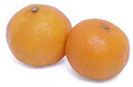

**Health Valueshttps://www.imtiaz.biz/resources/dot_blue.jpg**It is rich in Fiber and Vitamin C which is important for the production and maintenance of collagen.

**Shelf Lifehttps://www.imtiaz.biz/resources/dot_blue.jpg**Once treated with proper fungicide, waxed and and handled carefully to store the Kinnow at about 4°C. It can retain its freshness up to 60 days.

|  |
| --- |
| **Seasonal Availability: From November to April** |

**Eggs:-**

**The Incredible Egg: Farm Facts About Eggs**

* **Eggs** contain all the essential protein, minerals and vitamins, and **egg** yolks are one of the few foods that naturally contain Vitamin D.
* **Eggs** are good for your eyes because they contain lutein, which helps prevent age-related cataracts and muscle degeneration.
* An egg shell can have as many as 17,000 pores over its surface.
* The edible part of a chicken’s egg is approximately 74 percent water, 12 percent protein and 11 percent fat.
* China produces about 160 billion eggs per year, making it the largest egg producer in the world.
* There are roughly 280 million laying birds in the United States, and each produces 250 to 300 eggs a year.
* A chef’s hat is said to have a pleat for each of the many ways you can cook eggs.
* About 60 percent of eggs produced in the U.S. are used by consumers, and about 9 percent are used by the foodservice industry.
* Egg shell and yolk color can vary, and the color has no relation to egg quality, flavor, nutritive value, cooking characteristics or shell thickness.
* The breed of the hen determines the color of the egg shell, and it can range from white to deep brown. Among commercial breeds, hens with feathers and ear lobes lay white-shelled eggs and hens with red feathers and ear lobes lay brown-shelled eggs.
* Because breeds that lay brown eggs are typically slightly larger birds, they require more food, making brown eggs usually more expensive than white.

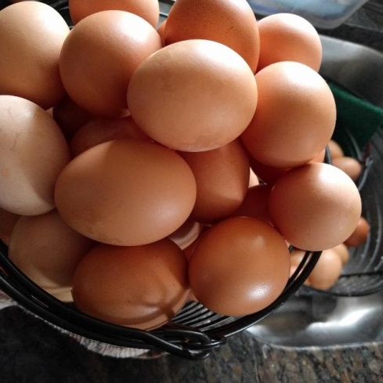

**Nutrition Facts:-**

* Raw Egg – per 100 gm

|  |  |
| --- | --- |
| **Calories** 143 | |
| **% Daily Value\*** | |
| **Total Fat** 10 g | 15% |
| Saturated fat 3.1 g | 15% |
| Polyunsaturated fat 1.9 g |  |
| Monounsaturated fat 3.7 g |  |
| Trans fat 0 g |  |
| **Cholesterol** 372 mg | 124% |
| **Sodium** 142 mg | 5% |
| **Potassium** 138 mg | 3% |
| **Total Carbohydrate** 0.7 g | 0% |
| Dietary fiber 0 g | 0% |
| Sugar 0.4 g |  |
| **Protein** 13 g | 26% |

|  |  |  |  |
| --- | --- | --- | --- |
| Vitamin A | 10% | Vitamin C | 0% |
| Calcium | 5% | Iron | 9% |
| Vitamin D | 20% | Vitamin B-6 | 10% |
| Cobalamin | 14% | Magnesium | 3% |

**Rice:- Cereal grain**

Rice is the seed of the grass species Oryza sativa or Oryza glaberrima. As a cereal grain, it is the most widely consumed staple food for a large part of the world's human population, especially in Asia. It is the agricultural commodity with the third-highest worldwide production, after sugarcane and maize.

Long-Grain: Roughly four times as long as it is wide, long-grain varieties of rice are most commonly used since they achieve everyday fluffy grains that stay separated.

Medium-Grain: Medium-grain rice is about twice as long as it is wide. Tender, moist, and a bit chewy, the grains tend to stick together a bit.

Short-Grain: Short-grain rice is short and plump. The grains stick together and clump up when cooked.

 Basmati rice is a long grain grown in India and Pakistan. This extremely fragrant variety gets its robust flavor from an aging process. Yep, it’s aged for about one year after harvesting. We love serving it with a simple curry to play up the grain’s natural aroma. You can also incorporate favorite vegetables and warm spices into the rice—like Plated’s take on [Lamb Biryani](https://www.plated.com/menus/2018-01-07/recipes/lamb-biryani-with-green-beans-and-pistachios?cvosrc=blog.morsel.13typesrice&utm_medium=blog&utm_source=morsel&utm_campaign=13typesrice&utm_ad=morsel).

Originally from Thailand, jasmine rice has a floral aroma. It is a long grain that cooks up soft and slightly sticky. Jasmine rice is the perfect choice for a dinner of Persian jeweled rice speckled with dried fruit. It also pairs well with Jamaican jerk chicken or a spicy curry.

 Brown rice comes in short or long grain varieties. It has been milled to remove the outer husk but retains its bran layer, which is chock-full of nutrients. Cooked brown rice boasts a subtly chewy texture and nutty flavor. You can swap in this grain for any dish that you would use white rice for. We like the way it adds a dose of heartiness to our favorite Chinese stir-fry or a dish of Mexican rice and beans.

Grown in India, matta or rosematta rice is a medium grain with a reddish color. Its bran layer is full of natural nutrients. Known for its robust earthy flavor, this variety calls for meaty accompaniments like lamb, beef, or game. It is well suited to slow-cooking stews and rich curries.

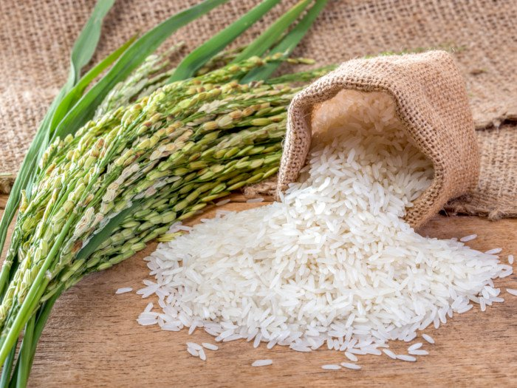

**Best Rice Types:**

1. **Basmati Rice**
2. **Chinese Black Rice**
3. **Jasmine Rice**
4. **Paella Rice**
5. **Risotto Rice**
6. **Sushi Rice**

**Countries producing rice are as follows;**

**India, China, Indonesia, Bangladesh, Japan, Pakistan, South Korea, Taiwan.**

* **And Pakistani (Basmati 370 or Pak Basmati), Basmati 385, Super Basmati or Best Aroma), Basmati Pak (Kernal), 386 or 1121 basmati rice, Basmati 515, Basmati 2000 and the Basmati 198).**

## Advantages of Basmati:-

Among the other[rice varieties](https://whatisthebestricecooker.com/what-is-the-best-white-rice-brand/), Basmati is one of those whose goodness and health advantages stand out. In fact, it is healthier in comparison with the white rice variety.

[Basmati rice](https://whatisthebestricecooker.com/what-is-the-difference-between-jasmine-and-basmati-rice/) has similar advantages to that of [brown rice](https://whatisthebestricecooker.com/what-is-the-best-brown-rice-brand-top-5-brands/) which is the [healthiest type of rice](https://whatisthebestricecooker.com/what-is-the-healthiest-type-of-rice/) varieties. The aroma of Basmati also aids in having good appetite plus it improves the taste of different Basmati rice recipes. Here are the following benefits of Basmati:

**1. High in Fiber**

The brown basmati rice is high in fiber content as compared to the white rice. The fibers in the bran layers which are still intact and stays during the milling process.

Thus, fiber helps in so many health benefits. One cup of basmati rice (200g) contains 20% of fiber contents (7.8g) which is ideal for adult recommended daily intake.

**2. Low Glycemic Index**

The glycemic index of brown basmati rice is considered on a ‘medium’ level wherein it is only around 56-69 while the white rice has 89.

**3. Assists in Fat Oxidation**

Basmati rice contains *oxoacetic acid*, which helps metabolize fats in our body. If this compound is not available, the fat is turned into ketones that can seriously lead to obesity and diabetes.

**4. Reduces Blood Pressure**

If you are suffering from high blood pressure then you can eat basmati rice in order to reduce and normalize. Basmati is rich in potassium and magnesium which regulates blood flow better.

**5. Improves Brain Performance**

For better and sharper memory, you need to eat basmati rice to improve your brain’s performance. Basmati is rich in thiamine that positively improves the nervous system as well as the overall well-being.

**6. Prevents Cancer Growth**

Because of its higher fiber contents, cancer cells are filtered out. Studies revealed that fiber-enriched food can greatly reduce the risk of any forms of cancer.

**7. Aids Regular Bowl Movement**

Fiber doesn’t just aid in preventing cancer growth but as well as maintaining regular bowel movement. Whole grain foods are the ones considered to be rich in fiber and the brown basmati rice contains one of the highest percentages.

**8. Gluten-Free**

Plenty of foods made from whole grain are naturally gluten-free. Basmati is organically gluten-free which is certified by most vegans and those with allergic reactions to gluten.

Other gluten-free food you can eat are milet, whole barley, whole wheat, spelt, brown rice, and quinoa.

**9. Rich in Vitamins and Minerals**

The aroma in basmati rice contains important vitamins such as: Vitamins B1 for healthy red blood cells, B6 for good metabolism, Vitamin E for anti-oxidant, Vitamin K for blood-clots, riboflavin and pantothenic acids for normal nervous system functioning.

**10. Promotes Stronger Bones**

Manganese is an essential mineral that is required for the body’s normal metabolism. Apart from that, manganese also improves the density of bones especially the spinal column. It prevents the buildup of osteoporosis and osteoarthritis.

|  |  |
| --- | --- |
| **Nutrition Facts:-**  **Rice, White, long grains, cooked**  **Amount per 100 gm**  **Calories 130** | |
| **% Daily Value\*** | |
| **Total Fat 0.3 g** | **0%** |
| **Saturated fat 0.1 g** | **0%** |
| **Polyunsaturated fat 0.1 g** |  |
| **Monounsaturated fat 0.1 g** |  |
| **Cholesterol 0 mg** | **0%** |
| **Sodium 1 mg** | **0%** |
| **Potassium 35 mg** | **1%** |
| **Total Carbohydrate 28 g** | **9%** |
| **Dietary fiber 0.4 g** | **1%** |
| **Sugar 0.1 g** |  |
| **Protein 2.7 g** | **5%** |

|  |  |  |  |
| --- | --- | --- | --- |
| **Vitamin A** | **0%** | **Vitamin C** | **0%** |
| **Calcium** | **1%** | **Iron** | **1%** |
| **Vitamin D** | **0%** | **Vitamin B-6** | **5%** |
| **Cobalamin** | **0%** | **Magnesium** | **3%** |